Assignment 1 – SQL & OOPS
TechShop, an electronic gadgets shop
Task:1 Database Design
1. Create the database named "TechShop"
create database TechShop;
2. Define the schema for the Customers, Products, Orders, OrderDetails and Inventory tables based on the provided schema.
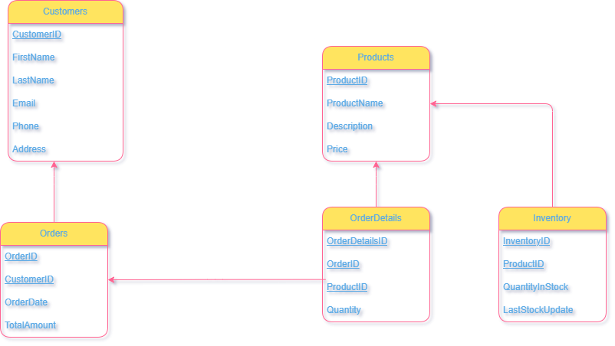

3. Create an ERD (Entity Relationship Diagram) for the database.
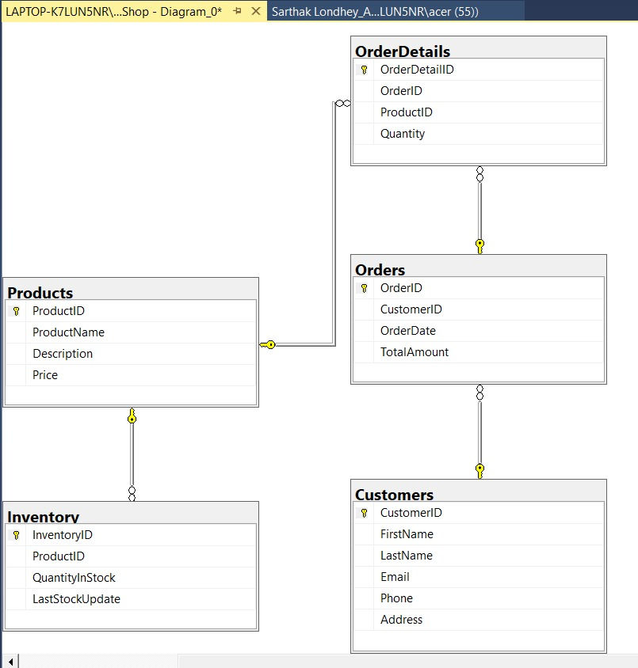
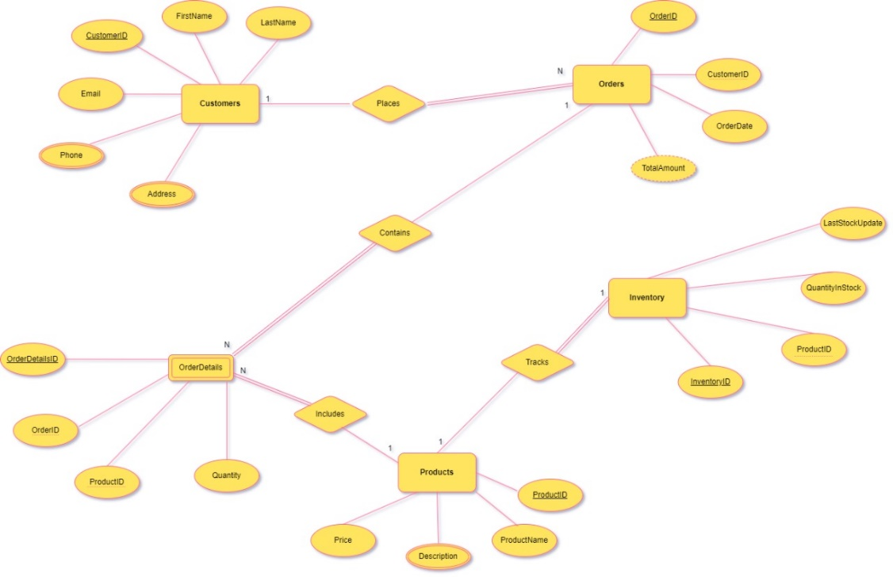
4. Create appropriate Primary Key and Foreign Key constraints for referential integrity.
CREATE TABLE Customers (
CustomerID INT PRIMARY KEY IDENTITY(1,1),
FirstName VARCHAR(50) NOT NULL,
LastName VARCHAR(50) NOT NULL,
Email VARCHAR(100) NOT NULL,
Phone VARCHAR(20),
Address VARCHAR(255)
);

CREATE TABLE Products (
ProductID INT PRIMARY KEY IDENTITY(1000,1),
ProductName VARCHAR(100) NOT NULL,
Description VARCHAR(MAX),
Price DECIMAL(10, 2) NOT NULL
);

CREATE TABLE Orders (
OrderID INT PRIMARY KEY IDENTITY(100,1),
CustomerID INT FOREIGN KEY REFERENCES Customers(CustomerID),
OrderDate DATE NOT NULL,
TotalAmount DECIMAL(10, 2) NOT NULL
);

CREATE TABLE OrderDetails (
OrderDetailID INT PRIMARY KEY IDENTITY(10000,1),
OrderID INT FOREIGN KEY REFERENCES Orders(OrderID),
ProductID INT FOREIGN KEY REFERENCES Products(ProductID),
Quantity INT
);

CREATE TABLE Inventory (
InventoryID INT PRIMARY KEY IDENTITY(100000,1),
ProductID INT FOREIGN KEY REFERENCES Products(ProductID),
QuantityInStock INT NOT NULL,
LastStockUpdate DATE NOT NULL
);
5. Insert at least 10 sample records into each of the following tables. a. Customers b. Products c. Orders d. OrderDetails.
Customers Table:
INSERT INTO Customers (FirstName, LastName, Email, Phone, Address) VALUES
('Khushi', 'Joshi', 'khushijoshi@gmail.com', '9876543210', '123, Sector 17, Indore, Madhya Pradesh'),
('Allu', 'Arjun', 'alluarjun@example.com', '8765432109', '456, Vijay Nagar, Bhopal, Madhya Pradesh'),
('Suryakumar', 'Yadav', 'suryakumaryadav@example.com', '7654321098', '789, Old City, Jaipur, Rajasthan'),
('Yash', 'Agrawal', 'yashagrawal@example.com', '6543210987', '1011, New Colony, Delhi, Delhi'),
('Prabhas', 'Raju', 'prabhasraju@example.com', '5432109876', '1234, Model Town, Mumbai, Maharashtra'),
('Piyush', 'Menaria', 'piyushmenaria@example.com', '4321098765', '5678, Banjara Hills, Hyderabad, Telangana'),
('Nishtha', 'Kaigaonkar', 'nishthakaigaonkar@example.com', '3210987654', '9012, Indiranagar, Bengaluru, Karnataka'),
('Vibhuti', 'Jain', 'vibhutijain@example.com', '2109876543', '1314, Salt Lake City, Kolkata, West Bengal'),
('Akshay', 'Kumar', 'akshaykumar@example.com', '1098765432', '1516, Beach Road, Chennai, Tamil Nadu'),
('Dharmesh', 'Yelande', 'dharmeshyelande@example.com', '9876543210', '1718, MG Road, Kochi, Kerala');
Products Table:
INSERT INTO Products (ProductName, Description, Price) VALUES
('iPhone 16 Pro', '6.1-inch Super Retina XDR display, A16 Bionic chip, 12MP dual camera system', 129999.00),
('Samsung Galaxy S24 Ultra', '6.8-inch Dynamic AMOLED 2X display, Snapdragon 8 Gen 2, 200MP camera', 119999.00),
('OnePlus 11', '6.7-inch Fluid AMOLED display, Snapdragon 8 Gen 2, 50MP camera', 59999.00),
('Xiaomi 13 Pro', '6.7-inch AMOLED display, Snapdragon 8 Gen 2, 50MP camera', 69999.00),
('Google Pixel 7 Pro', '6.7-inch LTPO OLED display, Google Tensor G2, 50MP camera', 84999.00),
('MacBook Pro M2', '13.3-inch Liquid Retina XDR display, M2 chip, 8GB RAM, 256GB SSD', 149999.00),
('Dell XPS 13', '13.4-inch InfinityEdge display, Intel Core i7-13700H, 16GB RAM, 512GB SSD', 129999.00),
('Lenovo ThinkPad X1 Carbon', '14-inch OLED display, Intel Core i7-13600H, 16GB RAM, 512GB SSD', 139999.00),
('HP Spectre x360', '13.3-inch AMOLED display, Intel Core i7-13600H, 16GB RAM, 512GB SSD', 129999.00),
('Acer Predator Helios 16', '16-inch IPS display, Intel Core i9-13900HX, 32GB RAM, 2TB SSD', 179999.00);

Orders Table:
INSERT INTO Orders (CustomerID, OrderDate, TotalAmount) VALUES
(1, '2023-11-25', 129999.00),
(2, '2023-12-01', 59999.00),
(3, '2023-12-10', 69999.00),
(4, '2023-12-15', 149999.00),
(5, '2023-12-20', 119999.00),
(6, '2023-12-25', 84999.00),
(7, '2024-01-01', 129999.00),
(8, '2024-01-05', 139999.00),
(9, '2024-01-10', 179999.00),
(10, '2024-01-15', 129999.00);
OrderDetails Table:
INSERT INTO OrderDetails (OrderID, ProductID, Quantity) VALUES
(100, 1000, 1),
(101, 1001, 1),
(102, 1002, 1),
(103, 1003, 1),
(104, 1004, 1),
(105, 1005, 1),
(106, 1006, 1),
(107, 1007, 1),
(108, 1008, 1),
(109, 1009, 1);
Inventory Table:
INSERT INTO Inventory (ProductID, QuantityInStock, LastStockUpdate) VALUES
(1000, 10, '2023-12-31'),
(1001, 15, '2023-12-31'),
(1002, 20, '2023-12-31'),
(1003, 5, '2023-12-31'),
(1004, 8, '2023-12-31'),
(1005, 12, '2023-12-31'),
(1006, 7, '2023-12-31'),
(1007, 11, '2023-12-31'),
(1008, 6, '2023-12-31'),
(1009, 9, '2023-12-31');
Tasks 2: Select, Where, Between, AND, LIKE
1. Write an SQL query to retrieve the names and emails of all customers.
SELECT FirstName, LastName, Email FROM Customers;
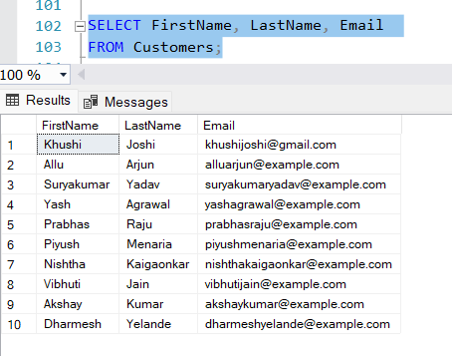

2. Write an SQL query to list all orders with their order dates and corresponding customer
names.
Select OrderDate, FirstName, LastName from Orders, Customers
Where Orders.CustomerID = Customers.CustomerID;
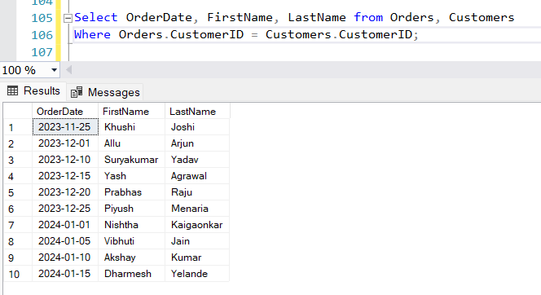

3. Write an SQL query to insert a new customer record into the "Customers" table. Include
customer information such as name, email, and address.
INSERT INTO Customers (FirstName, LastName, Email, Phone, Address)
VALUES ('Pihu', 'Mehta', 'mehtapihu@example.com', '1234567890', '456,Besatan,Surat, Gujrat');
select * from Customers;
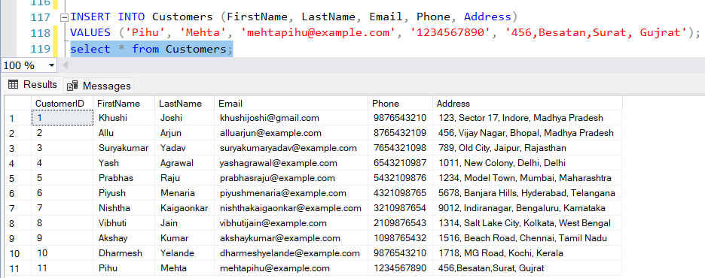

4. Write an SQL query to update the prices of all electronic gadgets in the "Products" table by increasing them by 10%.
UPDATE Products
SET Price = Price * 1.10;
select * from Products;
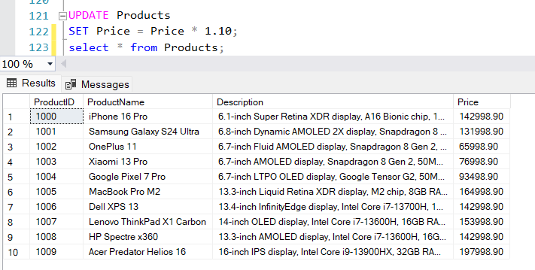

5. Write an SQL query to delete a specific order and its associated order details from the
"Orders" and "OrderDetails" tables. Allow users to input the order ID as a parameter.
declare @orderid int=102
DELETE FROM OrderDetails
WHERE OrderID = @orderid;
DELETE FROM Orders
WHERE OrderID = @orderid;
select * from OrderDetails;
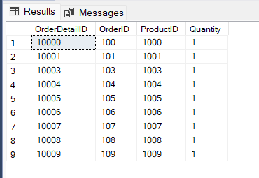

6. Write an SQL query to insert a new order into the "Orders" table. Include the customer ID, order date, and any other necessary information.
INSERT INTO Orders (CustomerID, OrderDate, TotalAmount)
VALUES (1, '2024-09-20', 79999.00);
select * from Orders;
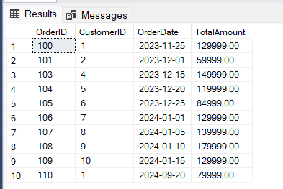

7. Write an SQL query to update the contact information (e.g., email and address) of a specific customer in the "Customers" table. Allow users to input the customer ID and new contact information.
UPDATE Customers
SET Email = 'newemail@example.com',
Address = '789, New Address, City, State'
WHERE CustomerID = 3;
select * from Customers;
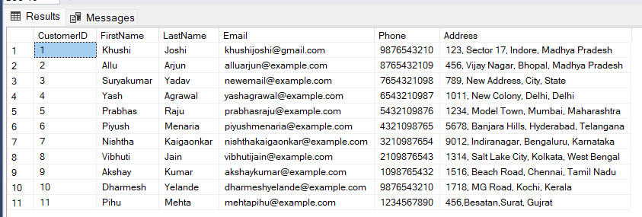

8. Write an SQL query to recalculate and update the total cost of each order in the "Orders" table based on the prices and quantities in the "OrderDetails" table.
UPDATE Orders
SET TotalAmount = (
SELECT (od.Quantity * p.Price)
FROM OrderDetails od
JOIN Products p ON od.ProductID = p.ProductID
WHERE od.OrderID = Orders.OrderID
);
select * from Orders;
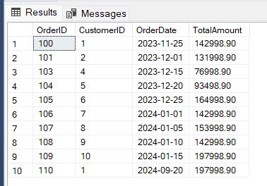

9. Write an SQL query to delete all orders and their associated order details for a specific
customer from the "Orders" and "OrderDetails" tables. Allow users to input the customer ID as a parameter.
DECLARE @CustomerID INT = 6
DELETE FROM OrderDetails
WHERE OrderID IN (
SELECT OrderID
FROM Orders
WHERE CustomerID = @CustomerID
);
DELETE FROM Orders
WHERE CustomerID = @CustomerID;
select * from OrderDetails;
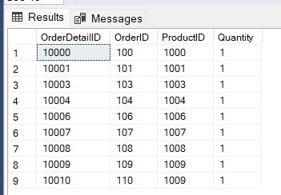

10. Write an SQL query to insert a new electronic gadget product into the "Products" table, including product name, category, price, and any other relevant details.
INSERT INTO Products (ProductName, Description, Price)
VALUES ('Smartwatch X200', 'A high-end smartwatch with various health tracking features and a sleek design.', 19999.00);
select * from Products;
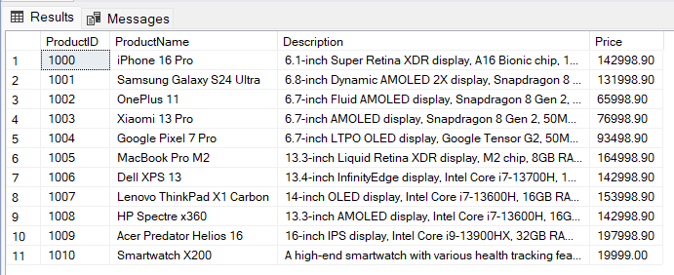

11. Write an SQL query to update the status of a specific order in the "Orders" table (e.g., from "Pending" to "Shipped"). Allow users to input the order ID and the new status.
ALTER TABLE Orders
ADD Status VARCHAR(50);
UPDATE Orders SET Status = 'Shipped' WHERE OrderID = 100;
UPDATE Orders SET Status = 'Pending' WHERE OrderID = 101;
UPDATE Orders SET Status = 'Pending' WHERE OrderID = 103;
UPDATE Orders SET Status = 'Delivered' WHERE OrderID = 106;
UPDATE Orders SET Status = 'Processing' WHERE OrderID = 107;
UPDATE Orders SET Status = 'Cancelled' WHERE OrderID = 108;
UPDATE Orders SET Status = 'Cancelled' WHERE OrderID = 109;
UPDATE Orders SET Status = 'Shipped' WHERE OrderID = 110;
UPDATE Orders SET Status = 'Shipped' WHERE OrderID = 104;
select * from Orders;
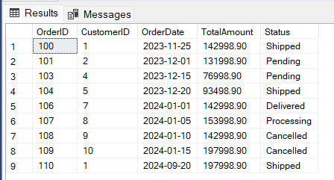
DECLARE @OrderID INT = 101
DECLARE @NewStatus VARCHAR(50) = 'shipped'
UPDATE Orders
SET Status = @NewStatus
WHERE OrderID = @OrderID;
select * from Orders;
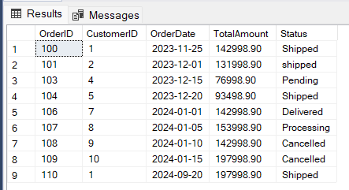

12. Write an SQL query to calculate and update the number of orders placed by each customer in the "Customers" table based on the data in the "Orders" table.
ALTER TABLE Customers
ADD OrderCount INT DEFAULT 0;
UPDATE Customers
SET OrderCount = (
SELECT COUNT(*)
FROM Orders
WHERE Orders.CustomerID = Customers.CustomerID
);
select * from Customers;
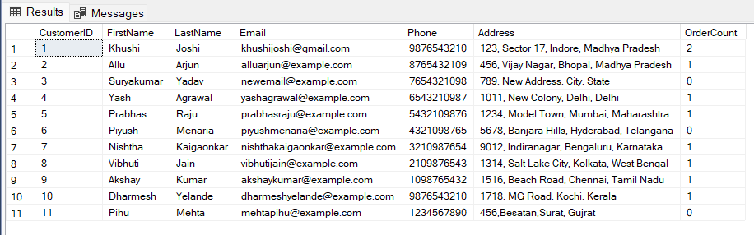

Task 3. Aggregate functions, Having, Order By, GroupBy and Joins
1. Write an SQL query to retrieve a list of all orders along with customer information (e.g.,
customer name) for each order.
SELECT O.OrderID, O.OrderDate, O.TotalAmount, C.FirstName, C.LastName, C.Email, C.Phone
FROM Orders AS O
JOIN Customers AS C ON O.CustomerID = C.CustomerID;
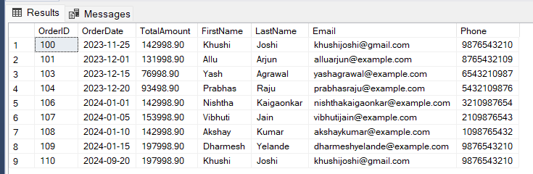

2. Write an SQL query to find the total revenue generated by each electronic gadget product. Include the product name and the total revenue.
SELECT P.ProductName, SUM(OD.Quantity * P.Price) AS TotalRevenue
FROM OrderDetails AS OD
JOIN Products AS P ON OD.ProductID = P.ProductID
GROUP BY P.ProductName;
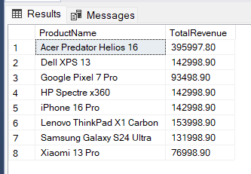

3. Write an SQL query to list all customers who have made at least one purchase. Include their names and contact information.
SELECT C.FirstName, C.LastName, C.Email, C.Phone
FROM Customers AS C
JOIN Orders AS O ON C.CustomerID = O.CustomerID
GROUP BY C.CustomerID, C.FirstName, C.LastName, C.Email, C.Phone;
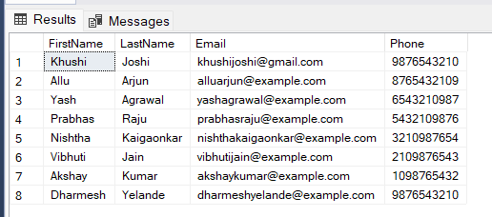

4. Write an SQL query to find the most popular electronic gadget, which is the one with the highest total quantity ordered. Include the product name and the total quantity ordered.
SELECT top 1 p.ProductName,
SUM(od.Quantity) AS TotalQuantityOrdered
FROM OrderDetails od
JOIN Products p ON od.ProductID = p.ProductID
JOIN Inventory i ON p.ProductID = i.ProductID
WHERE i.QuantityInStock > 0
GROUP BY p.ProductName
ORDER BY TotalQuantityOrdered DESC;
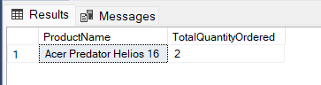

5. Write an SQL query to retrieve a list of electronic gadgets along with their corresponding
categories.
ALTER TABLE Products
ADD Categories VARCHAR(255);
UPDATE Products
SET Categories = 'Smartphones'
WHERE ProductID IN (1000, 1001, 1002, 1003, 1004);
UPDATE Products
SET Categories = 'Laptops'
WHERE ProductID IN (1005, 1006, 1007, 1008, 1009);
UPDATE Products
SET Categories = 'Smartwatches'
WHERE ProductID = 1010;

SELECT ProductName,
Categories AS CategoryName
FROM Products;
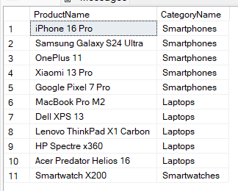

6. Write an SQL query to calculate the average order value for each customer. Include the
customer's name and their average order value.
SELECT c.FirstName,
c.LastName,
AVG(o.TotalAmount) AS AverageOrderValue
FROM Orders o
JOIN Customers c ON o.CustomerID = c.CustomerID
GROUP BY c.CustomerID, c.FirstName, c.LastName;
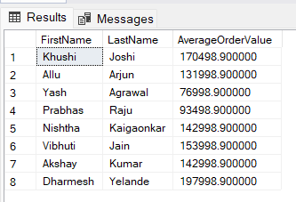

7. Write an SQL query to find the order with the highest total revenue. Include the order ID, customer information, and the total revenue.
SELECT o.OrderID,
c.FirstName,
c.LastName,
c.Email,
c.Phone,
o.TotalAmount AS TotalRevenue
FROM Orders o
JOIN Customers c ON o.CustomerID = c.CustomerID
WHERE o.TotalAmount = (
SELECT MAX(TotalAmount)
FROM Orders
);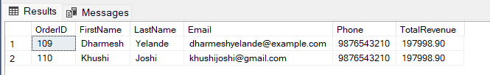

8. Write an SQL query to list electronic gadgets and the number of times each product has been ordered.
SELECT p.ProductName,
COUNT(od.OrderID) AS NumberOfOrders
FROM Products p
LEFT JOIN OrderDetails od ON p.ProductID = od.ProductID
GROUP BY p.ProductID, p.ProductName;
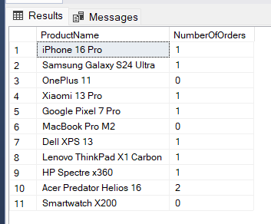

9. Write an SQL query to find customers who have purchased a specific electronic gadget product. Allow users to input the product name as a parameter.
DECLARE @ProductName NVARCHAR(255) = 'iPhone 16 Pro';
SELECT DISTINCT c.CustomerID,
c.FirstName,
c.LastName,
c.Email,
c.Phone
FROM Customers c
JOIN Orders o ON c.CustomerID = o.CustomerID
JOIN OrderDetails od ON o.OrderID = od.OrderID
JOIN Products p ON od.ProductID = p.ProductID
WHERE p.ProductName = @ProductName;
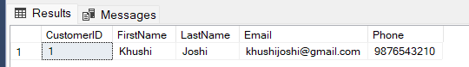

10. Write an SQL query to calculate the total revenue generated by all orders placed within a specific time period. Allow users to input the start and end dates as parameters.
DECLARE @StartDate DATE = '2023-11-01';
DECLARE @EndDate DATE = '2023-12-31';
SELECT SUM(TotalAmount) AS TotalRevenue
FROM Orders
WHERE OrderDate BETWEEN @StartDate AND @EndDate;
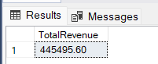
Task 4. Subquery and its type
1. Write an SQL query to find out which customers have not placed any orders.
SELECT c.CustomerID, c.FirstName, c.LastName, c.Email, c.Phone, c.Address
FROM Customers c
LEFT JOIN Orders o ON c.CustomerID = o.CustomerID
WHERE o.OrderID IS NULL;
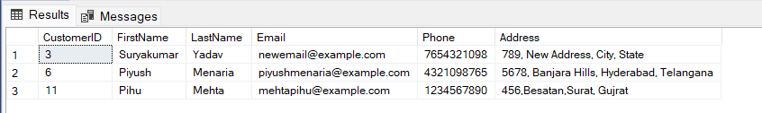

2. Write an SQL query to find the total number of products available for sale.
SELECT SUM(QuantityInStock) AS TotalProductsAvailable
FROM Inventory;
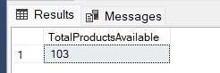

3. Write an SQL query to calculate the total revenue generated by TechShop.
SELECT SUM(TotalAmount) AS TotalRevenue
FROM Orders
WHERE Status IN ('Delivered', 'Shipped');
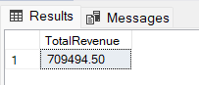

4. Write an SQL query to calculate the average quantity ordered for products in a specific category. Allow users to input the category name as a parameter.
SELECT p.Categories, AVG(od.Quantity) AS AvgQuantityOrdered
FROM Products p
JOIN OrderDetails od ON p.ProductID = od.ProductID
WHERE p.Categories = 'Laptops'
GROUP BY p.Categories;
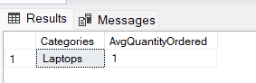

5. Write an SQL query to calculate the total revenue generated by a specific customer. Allow users to input the customer ID as a parameter.
DECLARE @customerID INT;
SET @customerID = 9;
SELECT c.CustomerID, CONCAT(c.FirstName, ' ', c.LastName) AS CustomerName, SUM(o.TotalAmount) AS TotalRevenue
FROM Customers c
JOIN Orders o ON c.CustomerID = o.CustomerID
WHERE c.CustomerID = @customerID
GROUP BY c.CustomerID, c.FirstName, c.LastName;
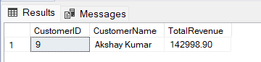

6. Write an SQL query to find the customers who have placed the most orders. List their names and the number of orders they've placed.
SELECT c.CustomerID, CONCAT(c.FirstName, ' ', c.LastName) AS CustomerName, COUNT(o.OrderID) AS OrderCount
FROM Customers c
JOIN Orders o ON c.CustomerID = o.CustomerID
GROUP BY c.CustomerID, c.FirstName, c.LastName
ORDER BY OrderCount DESC;
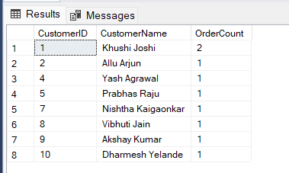

7. Write an SQL query to find the most popular product category, which is the one with the highest total quantity ordered across all orders.
SELECT TOP 1 p.Categories, SUM(od.Quantity) AS TotalQuantityOrdered
FROM Products p
JOIN OrderDetails od ON p.ProductID = od.ProductID
GROUP BY p.Categories
ORDER BY TotalQuantityOrdered DESC;
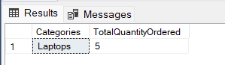

8. Write an SQL query to find the customer who has spent the most money (highest total revenue) on electronic gadgets. List their name and total spending.
SELECT TOP 1 C.FirstName, C.LastName, SUM(OD.Quantity * P.Price) AS TotalSpent
FROM Customers C
JOIN Orders O ON C.CustomerID = O.CustomerID
JOIN OrderDetails OD ON O.OrderID = OD.OrderID
JOIN Products P ON OD.ProductID = P.ProductID
GROUP BY C.FirstName, C.LastName
ORDER BY TotalSpent DESC;
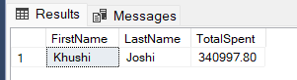

9. Write an SQL query to calculate the average order value (total revenue divided by the number of orders) for all customers.
SELECT C.CustomerID, C.FirstName, C.LastName, AVG(O.TotalAmount) AS AverageOrderValue
FROM Customers C
JOIN Orders O ON C.CustomerID = O.CustomerID
GROUP BY C.CustomerID, C.FirstName, C.LastName;
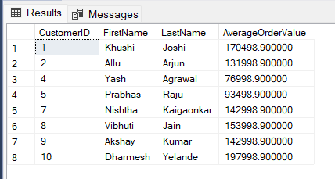

10. Write an SQL query to find the total number of orders placed by each customer and list their names along with the order count.
SELECT
c.FirstName,
c.LastName,
c.OrderCount as TotalOrders
FROM
Customers c
ORDER BY
TotalOrders DESC;
